Project Description
Thesis Title:
Pepper, the Moody Mood Lamp: A Colour Changing and Morphing Lamp for Exploring Human Robot Interaction, Artificial Life and Intuitive Reaction to Domestic Sound Events Through Machine Learning
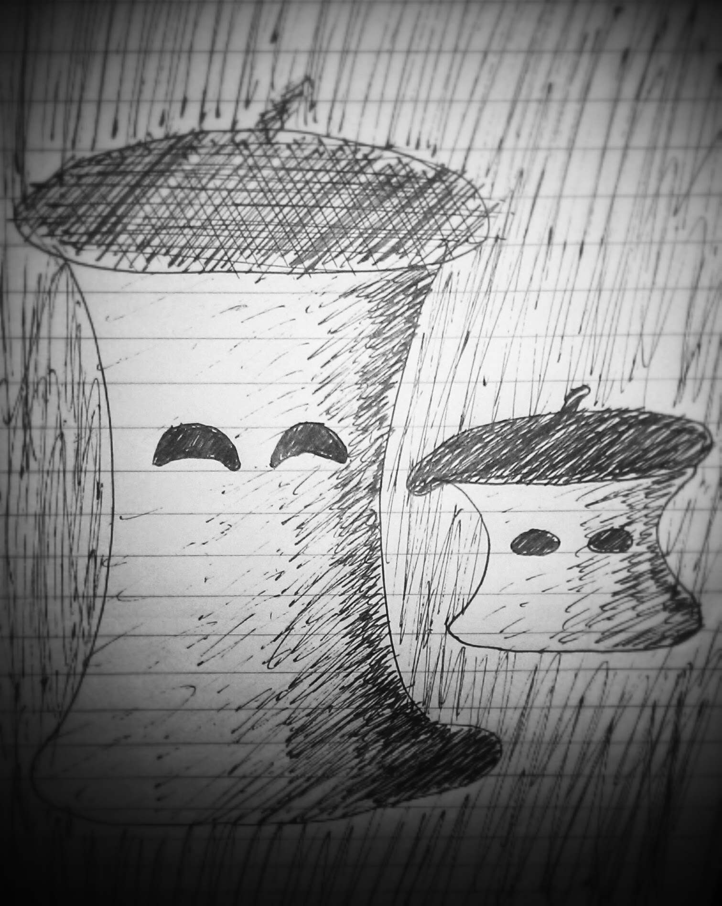

Formalities
Institute:
The Mærsk McKiney Møller Institute, University of Southern Denmark
Start Date:
1st of Oktober 2014

Submission Date:
1st of June 2015
This is a 40 ECTS points project:
- 10 points in the fall semester 2014,
- 30 points in the spring semester 2015.

Project supervisor:
Associate Professor, MMMI,
Poramate Manoonpong

Motivation
Two underlying motivating factors influence this project, creating artificial life and understanding deep learning algorithms. Experience with embodiment and the subsumption architecture is a learning choice opposed by painstakingly thought out complicated final state machines. Simplicity and evolution is key in this project which fits well with the subsumption ideas. As introduced by Rodney Brooks, embodiment seems to be an effective way of developing complex and robust biological behaviours iteratively from simple components. Deep learning is a popular new machine learning approach capable of achieving some of the most accurate and general classification results of contemporary techniques. What better way to learn about these kind of algorithms than to implement them on a robot, first using pre-trained knowledge/rules, but especially when it itself should learn and improve automatically from data it collects during its operation. The other aspect of artificial life is driven by the ever closer realization of intelligent robot entering the world in all of its facets, from industry to companionship. Trying to predict the final form of robots at the turn of this century would be naive, but exploration of the possibilities of robotics of our own present time could most certainly be beneficial and interesting none the less. The specific strand of research involving animal/human-like behaviours and means of communication is deemed relevant due to the fact that we inescapably are humans with behaviours to fit. There are surprisingly many dimensions to our own interaction with each other, all of which come natural to us, e.g. reinforcing speech with hand gestures or raising an eyebrow to influence the meaning of a certain statement. Utilizing these often pseudo-subconscious gestures have the potential to ease interaction with computers and robots significantly. An extreme extrapolation of this idea is to create artificial life with behaviours similar to our own in order to achieve both optimal communication, but not least a new species to interact with.

Objective
As an educational project, researching and implementing machine learning techniques and artificial life models are main objectives in themselves. These are however deeply integrated in the objective of developing a living mood lamp robot, that reacts intuitively to domestic sound events. Through this, obtain experience with theory an implementation of machine learning techniques and artificial life models. This robot can be arbitrarily complicated, so the project will be constrained to working with the most essential parts that make up such a robot. These parts are:

Robot Platform
Improve the Pepper robot lamp platform with e.g. the following features:
  - body with 5 DOF constrained movement(large spring, tendons and servos)
  - Powerful 220V RGB LED bulb for lighting and reinforcement of emotion
  - Expressive eyes, that can covey emotion
  - Directional sound input
  - Ambient light sensor

Sound Event clustering
Use machine learning to cluster unique sound events from continuous sound, e.g.:
- Sudden or constant noises (especially whether new to the robot or not)
- speech(including tone of voice) directed at the robot vs. conversation
- music(rhythm).

Then, with these clusters, define appropriate reactions, and severity, which fit the robots identity as a small living mood lamp, e.g. looking towards a new sound or speech source, ignoring irrelevant or well known sounds, changing mood or following rythm of music. The data would come in form of sounds in a room and labeled live, right or wrong, by the human which observe whether the robots reaction is appropriate.

Artificial Life
Incorporate relevant artificial-life aspects to reinforce the goal, e.g. mood, attention and habituation, curiosity, drive(e.g . Social vs. Entertainment, vs. rest) and motivation, based on research from robots like Kismet or Keepon.

Preliminary work and project delimitation
This project expands upon the Pepper robot platform, developed as a project in the course AI4 of the 2014 autumn semester. Pepper consists of a cylindrically shaped body made of white cloth over a simple rigid skeleton with 1DOF swivel movement and a powerful RGB LED for lighting. It has directional microphones a input. It is capable recognizing difference between positive and negative tone of voice using machine learning and reacts accordingly by changing its own mood, expressed by colour and eye shape.

The focus will be on clustering different sound events and estimating their relative novelty to the robot, with each class sparking an appropriate reaction. A part of the project is also to figure out what behaviours are essential with the product goal in mind. Not all the desired features can be implemented fully in one project, but their mention reinforce the prospect of the robots as a whole, justifying working on the essential features.

The design of the robot platform is pretty far ahead and will be simple, but fitting to the robots identity as a living mood lamp.

Project Requirements

Documentation
Documentation will be in the form of a comprehensive technical and scientific thesis report, describing both relevant theory, technical design choices and experimental results.

Product Evaluation
Scientific experiments will be conducted in order to evaluate the performance of each individual behavioural feature. Additionally, a survey evaluating the overall performance of the robot will be conducted, based on a small set users', specifically how they react to the robot in its target environment.

Project Plan
Week 40-43: Develop design ideas
Week 44-48: Research deep learning and artificial life theory; work on preliminary project.
Week 49-52: Research theory and improve robot platform; finish preliminary project
Week 1-4: Implement Clustering algorithm, implement robot behaviours(movement, mood change)
Week 5-9: Improve Clustering, implement artificial life features.
Week 10-13: Combine behaviours with input data analysis
Week 14: Tie together loose ends and optimize overall robot performance
Week 15-16: Experiments, individual technical features
Week 17: Experiment, overall robot performance
Week 18-21: Document development process and experiments
Week 22: Documentation finished, proof read.
01/06, Week 23: Hand in Thesis

Learning Goals:
As an educational project, several general learning goals have been defined. The following is taken from the official SDU course description:

Knowledge
The student
- is able to account for relevant engineering skills based on the highest level of international research within the subject area of the programme
- has a good understanding of - and be able to reflect on - relevant knowledge within the subject area of the programme
- is able to identify relevant scientific problems within the subject area of the programme

Skills
The student
- is able to assess, select and apply scientific methods, tools and competencies within the subject area of the course
- is able to present novel analysis and problem-solving models
- is able to explain and discuss relevant professional and scientific problems
- is able to communicate in writing in a clear and understandable manner

Competence
The Student
- is able to manage work and development situations that are complex and unforeseen and require new solution models
- is able to independently initiate and carry out discipline-specific and cross disciplinary cooperation and to assume professional responsibility
- is able to independently take responsibility for his/her own professional development and specialization
- is able to disseminate research-based knowledge

Student Information
Title and Name:
BSc. Lasse Simmelsgaard Børresen

Contact Information:
Phone: 0045 41356060
Email: laboe10@student.sdu.dk
Address: Absalonsgade 19 St. 3, 5000 Odense C, Denmark



